**BLYNK HEALTH MONITORING SYSTEM**

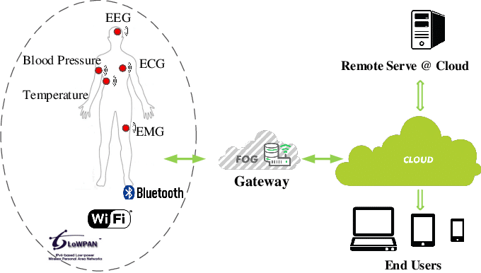

**INTRODUCTION**

In this IoT Project, we will make a Health Monitoring Device that can measure heart rate in BPM (Beat per Minute) and SpO2 (percentage of oxygen in the blood). This device can be used by peoples to monitor their heart rate and blood oxygen levels during a work. The Best part of this project is that we can connect this device to an Android app Blynk that will record and regularly update the data for both SPO2 & BPM on the internet. Anyone can monitor the data from any part of the world as data are uploaded on server.

As there is an availability of online data, so this project can be used to monitor the health of a patient online. The pulse oximeter available in the market is very expensive, but with this simple & low-cost pulse oximeter module, we can make our own device. So let’s learn how to make MAX30100 Pulse Oximeter with ESP8266.

**IMPORTANT FEATURES**

* ESP8266 will generate the output.
* The doctor can check the current condition of the patient using his smartphone.
* Use of firebase for run-time data.
* Communication between ESP8266 and android app needed.
* This IoT model uses WiFi technology.

**FLOWCHART**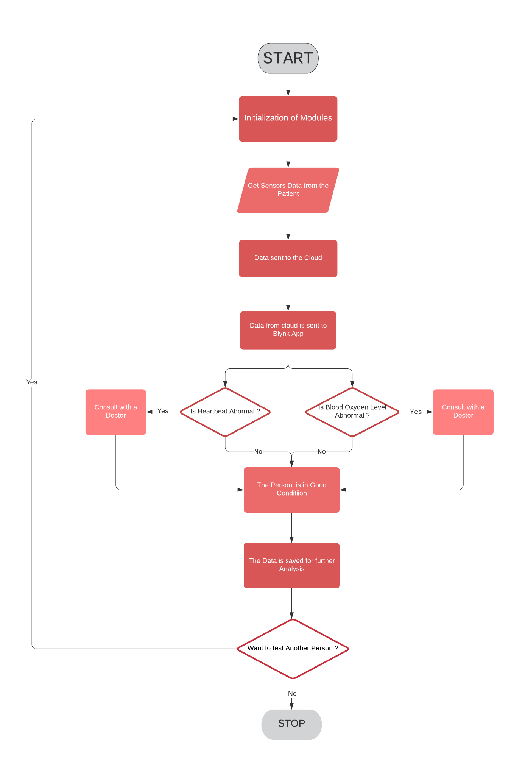

**COMPONENTS**

* **ESP8266**

The ESP8266 is a low-cost Wi-Fi microchip, with a full TCP/IP stack and Microcontroller capability.

The Wi-Fi module is a self-contained SOC with integrated TCP/IP protocol stack that can give any microcontroller access to your Wi-Fi network. The ESP8266 is capable of either hosting an application on offloading all Wi-Fi networking functions from another application processor.

Connecting to the Wi-Fi module through a TP Link WR841N router. It is able to ping the module at 479m with a huge rubber duck antenna soldered on or 366 meters with the PCB antenna.

* Max30100 Pulse Oximeter

Max30100 is an integrated pulse oximeter and heart-rate monitor sensor solution. It’s an optical sensor that derives its readings from emitting two wavelength of light from two LEDs.

The pin configuration of Max30100 Pulse Oximeter Heart Rate Sensor Module is :-

|  |  |  |
| --- | --- | --- |
| Sl. No. | PINS | DEFINITION OF PINS |
| 1 | VIN | Input Voltage (1.8-5.5)V |
| 2 | SCL | IIC-SCL |
| 3 | SDA | IIC-SDA |
| 4 | INT | MAX30100 INT |
| 5 | IRD | MAX30100 IR_DRV |
| 6 | RD | MAX30100 R_DRV |
| 7 | GND | GROUND |

* OLED

An organic light – emitting diode, alsoknown as an organic EL diode, is a light-emitting diode (LED) in which the emissive electroluminescent layer is a film of organic compound that emits light in response to an electric current.

The main component in an OLEDs display is the OLED emitter-an organic (carbon-based) material that emits light when electricity is applied. The basic structure of an OLED is an emissive layer Sandwiched between a cathode and an anode.

* Breadboard

A breadboard is a solderless device for temporary prototype with electronics and test circuit designs. Most electronic components in electronic circuits can be interconnected by inserting their leads or terminals into the holes and then making connections through wires where appropriate.

* Jumper wires

Jumper wires are simply wires that have connector pins at each end, allowing them to be used to connect two points to each other without soldering. Jumper wires are typically used with breadboards and other prototyping tools in order to make it easy to change a circuit as needed.

* Blynk App Protocols

Blynk is an open source android app which is designed and developed in order to control the hardware via internet of things (IOT). This digitally displays sensor data, it can accumulate and visualize the data. This app gives us to create amazing interfaces for a project using multiple widgets which is an in build app. It acts as an interface between the smartphone and hardware which is responsible for the communication.

NETWORK PROTOCOLS

Hypertext Transfer Protocol Secure is an extension of the Hypertext Transfer Protocol. It is used for secure communication over a computer network, and is widely used on the Internet. In HTTPS, the communication protocol is encrypted using Transport Layer Security or, formerly, Secure Sockets Layer.

**CLOUD PLATFORMS**

A cloud provider API is an application program interface that allows the end user to interact with a cloud provider's service. This provides the cloud customer with the ability to use a single API call to access cloud resources on more than one provider's cloud computing platform.

API stands for Application Programming Interface. An API is a software intermediary that allows two applications to talk to each other. In other words, an API is the messenger that delivers our request to the provider that we're requesting it from and then delivers the response back to us.

**CIRCUIT DIAGRAM**

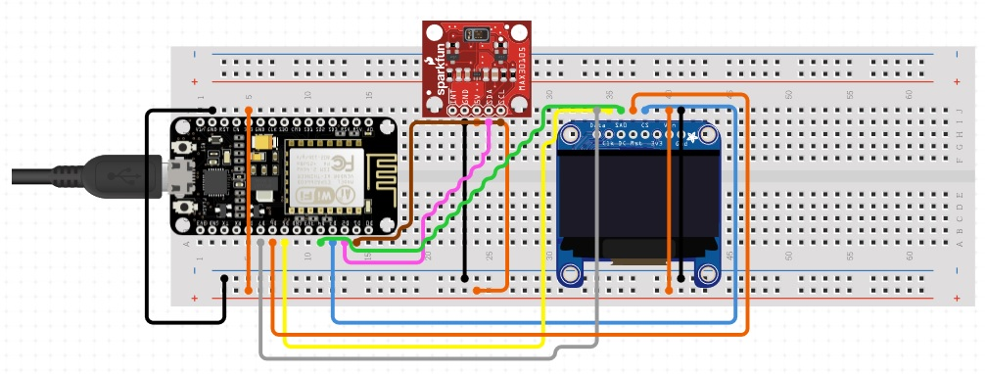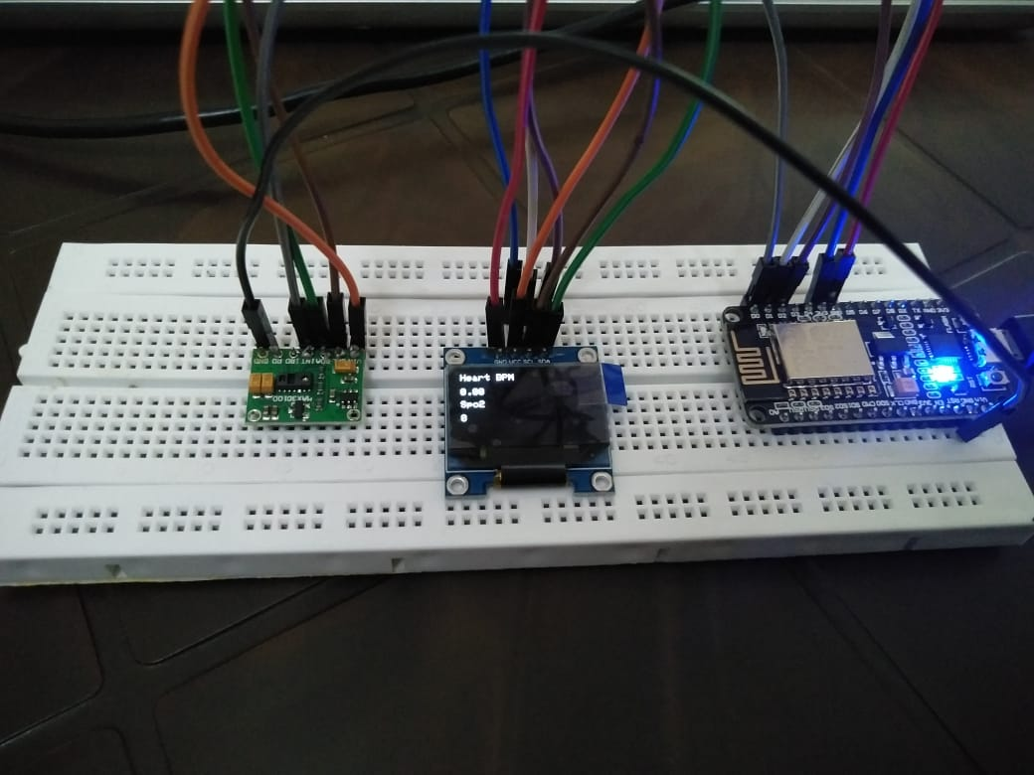

**SCHEMATIC DIAGRAM**

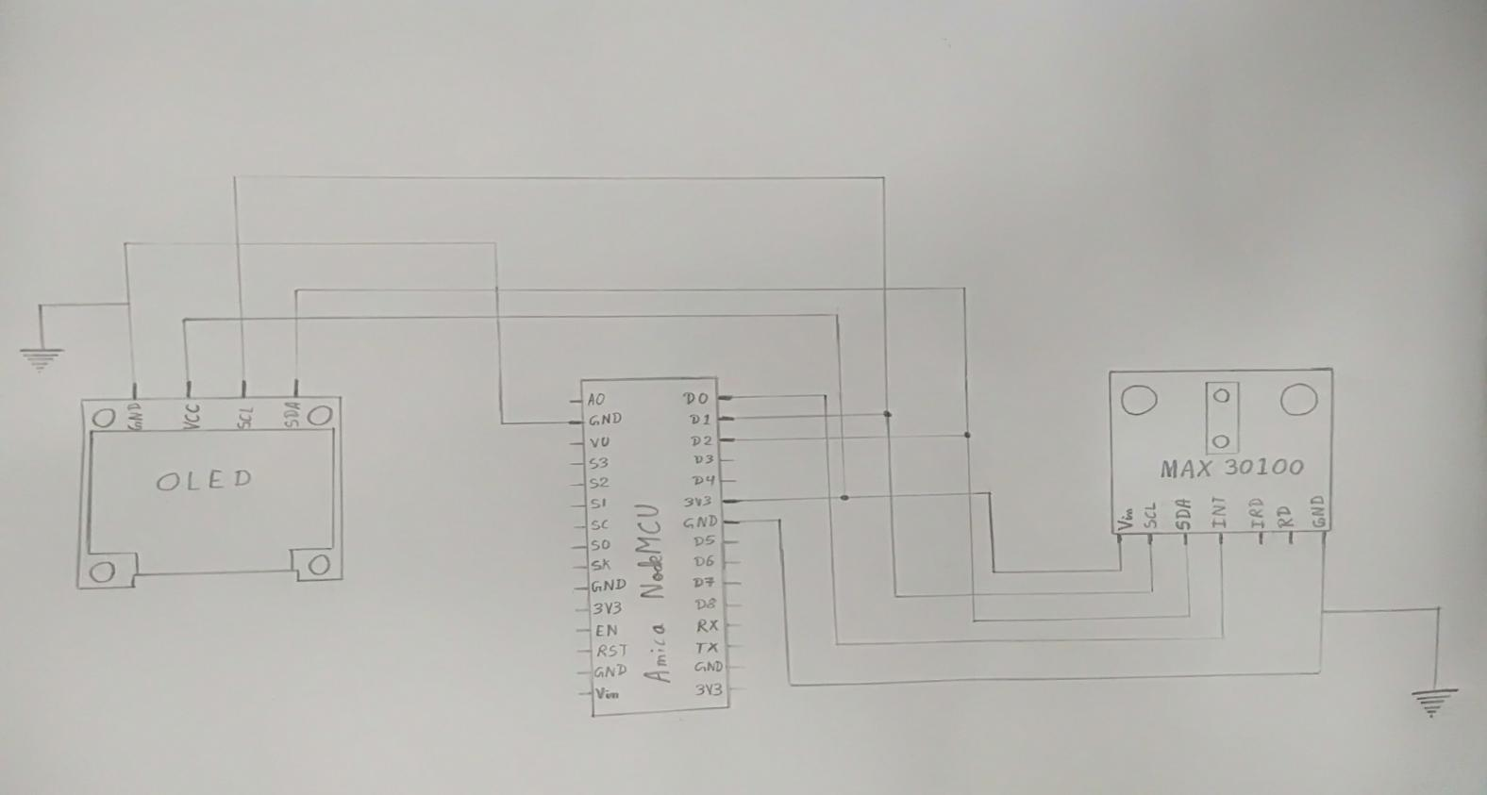**CODE**

#include <Wire.h>

#include "MAX30100_PulseOximeter.h"

#define BLYNK_PRINT Serial

#include <Blynk.h>

#include <ESP8266WiFi.h>

#include <BlynkSimpleEsp8266.h>

#include "Wire.h"

#include "Adafruit_GFX.h"

#include "OakOLED.h"

#define REPORTING_PERIOD_MS 1000

OakOLED oled;

char auth[] = "N-81lOStH83VwUeNuKHOzpLVzqjFXhHO"; // You should get Auth Token in the Blynk App.

char ssid[] = "CPH1801"; // Your WiFi credentials.

char pass[] = "12345679";

// Connections: SCL PIN - D1, SDA PIN - D2, INT PIN - D0

PulseOximeter pox;

float BPM, SpO2;

uint32_t tsLastReport = 0;

const unsigned char bitmap [] PROGMEM=

{

0x00, 0x00, 0x00, 0x00, 0x01, 0x80, 0x18, 0x00, 0x0f, 0xe0, 0x7f, 0x00, 0x3f, 0xf9, 0xff, 0xc0,

0x7f, 0xf9, 0xff, 0xc0, 0x7f, 0xff, 0xff, 0xe0, 0x7f, 0xff, 0xff, 0xe0, 0xff, 0xff, 0xff, 0xf0,

0xff, 0xf7, 0xff, 0xf0, 0xff, 0xe7, 0xff, 0xf0, 0xff, 0xe7, 0xff, 0xf0, 0x7f, 0xdb, 0xff, 0xe0,

0x7f, 0x9b, 0xff, 0xe0, 0x00, 0x3b, 0xc0, 0x00, 0x3f, 0xf9, 0x9f, 0xc0, 0x3f, 0xfd, 0xbf, 0xc0,

0x1f, 0xfd, 0xbf, 0x80, 0x0f, 0xfd, 0x7f, 0x00, 0x07, 0xfe, 0x7e, 0x00, 0x03, 0xfe, 0xfc, 0x00,

0x01, 0xff, 0xf8, 0x00, 0x00, 0xff, 0xf0, 0x00, 0x00, 0x7f, 0xe0, 0x00, 0x00, 0x3f, 0xc0, 0x00,

0x00, 0x0f, 0x00, 0x00, 0x00, 0x06, 0x00, 0x00, 0x00, 0x00, 0x00, 0x00, 0x00, 0x00, 0x00, 0x00

};

void onBeatDetected()

{

Serial.println("Beat Detected!");

oled.drawBitmap(60, 20, bitmap, 28, 28, 1);

oled.display();

}

void setup()

{

Serial.begin(115200);

oled.begin();

oled.clearDisplay();

oled.setTextSize(1);

oled.setTextColor(1);

oled.setCursor(0, 0);

oled.println("Initializing pulse oximeter..");

oled.display();

pinMode(16, OUTPUT);

Blynk.begin(auth, ssid, pass);

Serial.print("Initializing Pulse Oximeter..");

if (!pox.begin())

{

Serial.println("FAILED");

oled.clearDisplay();

oled.setTextSize(1);

oled.setTextColor(1);

oled.setCursor(0, 0);

oled.println("FAILED");

oled.display();

for(;;);

}

else

{

oled.clearDisplay();

oled.setTextSize(1);

oled.setTextColor(1);

oled.setCursor(0, 0);

oled.println("SUCCESS");

oled.display();

Serial.println("SUCCESS");

pox.setOnBeatDetectedCallback(onBeatDetected);

}

// The default current for the IR LED is 50mA and it could be changed by uncommenting the following line.

//pox.setIRLedCurrent(MAX30100_LED_CURR_7_6MA);

}

void loop()

{

pox.update();

Blynk.run();

BPM = pox.getHeartRate();

SpO2 = pox.getSpO2();

if (millis() - tsLastReport > REPORTING_PERIOD_MS)

{

Serial.print("Heart rate:");

Serial.print(BPM);

Serial.print(" bpm / SpO2:");

Serial.print(SpO2);

Serial.println(" %");

Blynk.virtualWrite(V7, BPM);

Blynk.virtualWrite(V8, SpO2);

oled.clearDisplay();

oled.setTextSize(1);

oled.setTextColor(1);

oled.setCursor(0,16);

oled.println(pox.getHeartRate());

oled.setTextSize(1);

oled.setTextColor(1);

oled.setCursor(0, 0);

oled.println("Heart BPM");

oled.setTextSize(1);

oled.setTextColor(1);

oled.setCursor(0, 30);

oled.println("Spo2");

oled.setTextSize(1);

oled.setTextColor(1);

oled.setCursor(0,45);

oled.println(pox.getSpO2());

oled.display();

tsLastReport = millis();

}

}

**SUSTAINABILITY**

By definition, sustainability aims to promote healthy, viable, and equitable communities. The challenge is the current approach to delivering health and care cannot continue in the same way and stay within these limits. A sustainable health and care system is achieved by delivering high quality care and improved public health.

**OUR PROJECT’S ADVANTAGES**

* Allows sending data from patients to health professionals in real time.
* Improves patient’s lifestyle.
* Makes health care more available.
* Saves money.

**CONCLUSION & FUTURE WORK**

In this paper, we found the importance and fruitful benefits of implementation of Internet of Things in remote health monitoring systems. The compact sensors with IoT will make a huge impact on every patient’s life, that even though they are away from home and physician, this helps them to reduce the fear of danger. The sensory data can be acquired in home or work environments. Also, the challenges in sensing, analytics and prediction of the disease are also highlighted and those can be addressed to provide a seamless integration into the medical field.

Data from the wearable sensors will undergo the process of pattern recognition and machine learning techniques. In order to handle with more heterogeneous and constantly changing sensor data, machine learning must be developed further. Also, those algorithms must be capable of dealing with inevitably missing data values, streaming data and information of varying dimensionality and semantics as the design of sensors often change.

**GROUP MEMBERS**

1. **Subhankar Samanta.(1904232)**
2. **Siddharth Prusty.(1904226)**
3. **Nilab Nath.(1807285)**
4. **Surabhi Kumari.(1904234)**